KS2 Visit Booklet Answers

GreenWood Sustainability Quiz

- It exports it to the grid
- Paper, cardboard
- 15,000 tons
- it is processed into biodiesel
- Anglesey
- 130 cubic metres
- Wood

Snowdon View

- F – it is the largest in Wales, but Ben Nevis is the highest in the Britain
- T
- T
- T
- T – because it has well-established paths which lead all the way to the summit. It can also be reached by the Snowdon Railway Line.
- T

Forces questions: Most rides, including Solar Splash, Zipideedoodah and the Great Green Run rely on gravity to move and friction to slow. Solar Splash uses strong pumps to get the water to the top of the ride, which are powered by the solar panels. Older children may discuss air and water resistance as forms of friction.

None of these rides would therefore work in space, where there is no gravity.

One of these pictures shows a non-renewable source of energy. Which one?
Fossil fuels

What does non-renewable mean? It is running out/not capable of being replenished.

_______________________

Fossil fuels
Like coal, oil and gas

Geothermal
(Energy from the heat of the Earth)

Wind
(Energy from the wind)

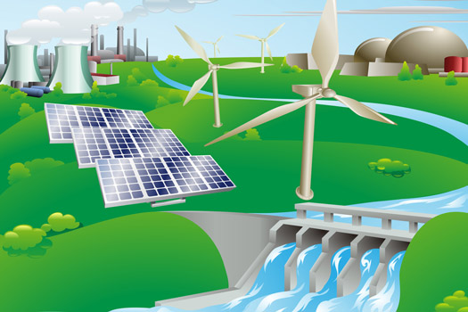
Earth fossil fuels oil sun wind water biomass hydropower solar geothermal plants

Biomass
(Energy from plants)

Hydropower
(Energy from the force of moving water

Solar
(Energy from the sun)

