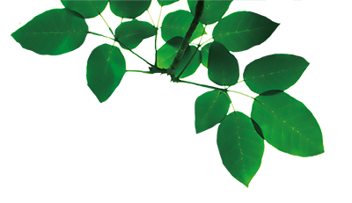
A New Ride For GreenWood!

Can you design your own new ride/attraction for GreenWood Forest Park?

Think carefully about how your ride might operate in a sustainable way. Annotate your drawing and give your ride an exciting name.

