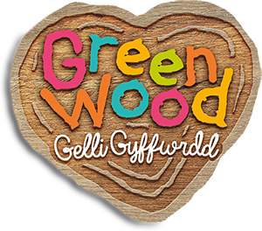
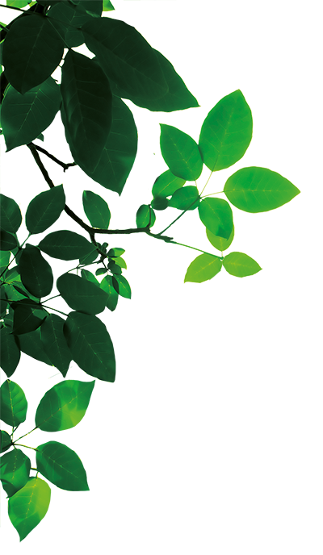
Name:
Date:
GreenWood Sustainability Wordsearch
N | E | N | V | I | R | O | N | M | E | N | T | G | N | H
G | N | S | O | W | A | E | S | I | L | P | L | S | O | T
F | E | N | E | R | S | Y | A | G | E | L | I | O | N | N
Y | R | V | N | U | G | A | G | L | M | O | S | A | R | E
S | G | T | E | N | N | U | B | E | N | E | S | S | E | M
O | Y | R | S | O | L | A | R | P | O | W | E | R | N | N
L | S | F | B | G | W | O | I | E | G | R | F | W | E | O
P | T | R | W | E | A | C | O | A | L | O | B | Y | W | R
A | A | S | N | M | O | A | O | R | G | W | A | E | A | I
C | M | E | N | K | E | R | U | T | U | F | S | N | B | V
C | R | E | C | Y | C | L | E | H | R | A | C | E | L | N
P | P | E | O | P | L | E | P | O | W | E | R | G | E | E
L | N | S | L | E | U | F | L | I | S | S | O | F | L | H
Y | T | I | L | I | B | A | N | I | A | T | S | U | S | C
E | V | I | R | M | E | S | V | Y | O | I | M | N | I | T

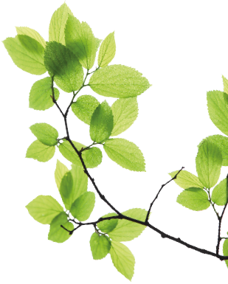

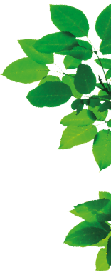
How many of the bold words can you find in the wordsearch?

- Nearly all of the energy we use, we get from the earth. We burn fossil fuels (coal, oil and gas) to produce electricity. This produces carbon dioxide, which is bad for the environment.

- Fossil fuels are non-renewable which means once we have used them, they have gone.

- There are more environmentally friendly ways of getting energy, like solar power. This is a renewable resource, which means it won’t run out.

- Sustainability is about acting responsibly about the products we use in order to be able to support the billions of people who will live on our planet in the future.

- To help the environment, GreenWood tries to reuse and recycle as much as possible so there is less waste. The park relies mostly on people power and solar power, so it has a low carbon footprint.

Solution

 | E | N | V | I | R | O | N | M | E | N | T |  | N
 | N |  |  |  |  | E | S |  |  |  |  |  | O | T
 | E |  |  |  | S |  | A |  | E | L | I | O | N | N
 | R |  |  | U |  |  | G | L |  |  |  |  | R | E
 | G |  | E |  | N |  | B |  |  |  |  |  | E | M
 | Y | R | S | O | L | A | R | P | O | W | E | R | N | N
 |  |  | B |  | W |  |  | E |  |  |  |  | E | O
 |  | R |  | E |  | C | O | A | L |  |  |  | W | R
 | A |  | N |  |  |  |  | R |  |  |  |  | A | I
C |  | E |  |  | E | R | U | T | U | F |  |  | B | V
 | R | E | C | Y | C | L | E | H |  |  |  |  | L | N
 | P | E | O | P | L | E | P | O | W | E | R |  | E | E
 |  | S | L | E | U | F | L | I | S | S | O | F
Y | T | I | L | I | B | A | N | I | A | T | S | U | S

